**EX NO: 12 CLOUD PERFORMANCE ANALYSIS USING CLOUD ANALYST**

**AIM**:

To perform cloud performance analysis using cloud analyst tool

**PROCEDURE & SCREENSHOTS:**

1. Download and Open cloud analyst tool from bat file from the extracted cloud analyst zip file

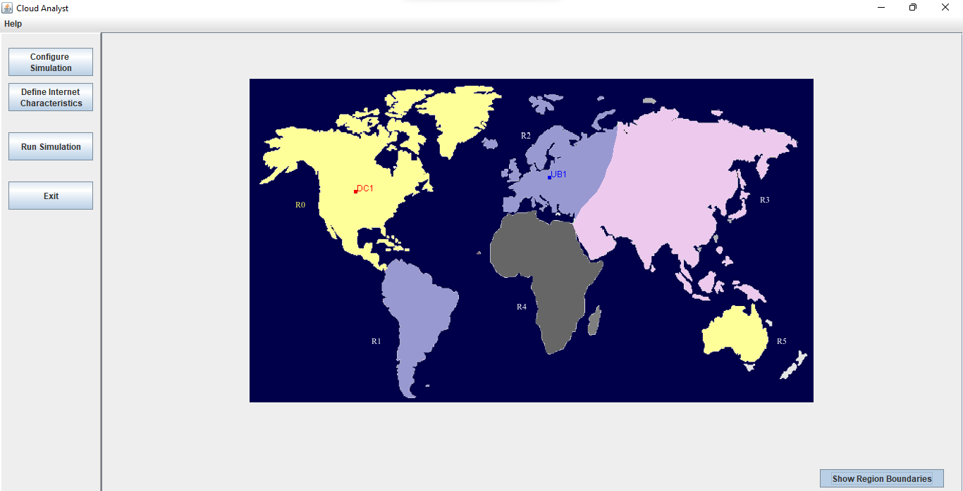

1. The boundaries are shown now

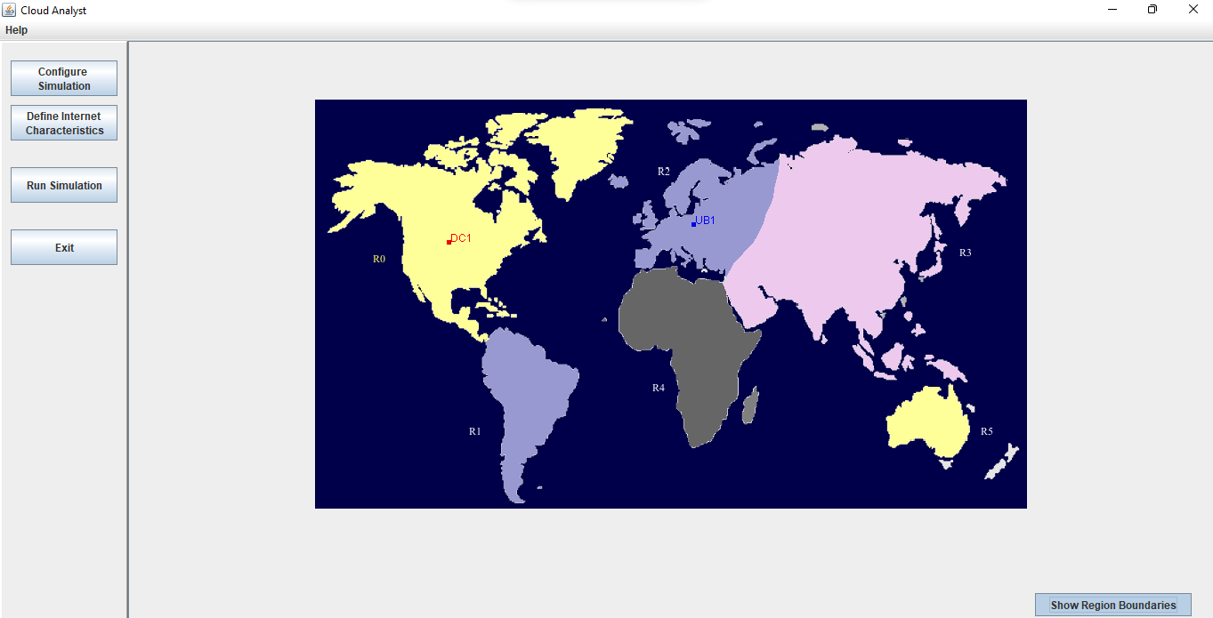

1. Click configure simulation

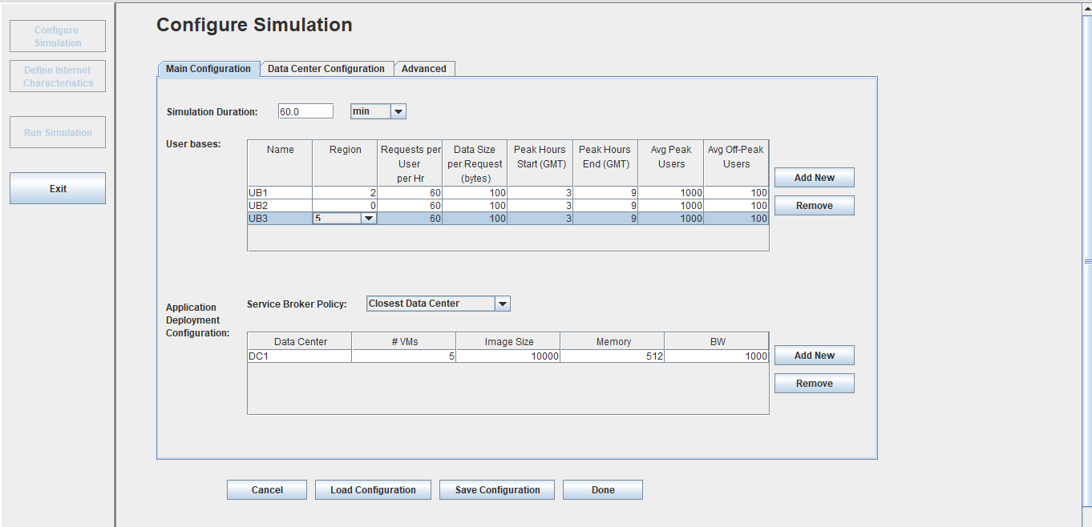

1. Add datacentre

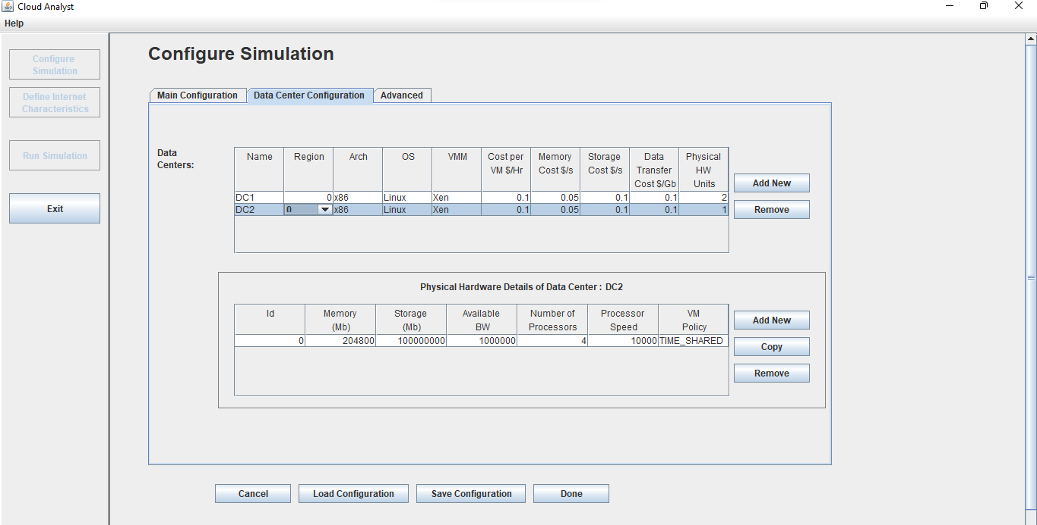

1. Add it in main configuration and check the service broker policy if needed

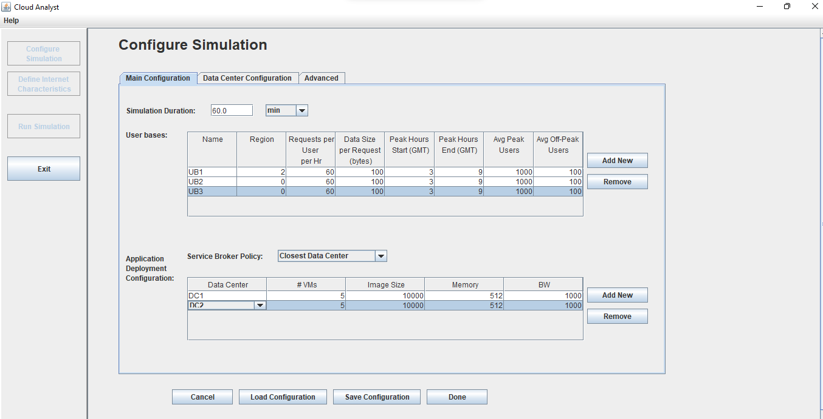

1. Change advanced configuration if needed

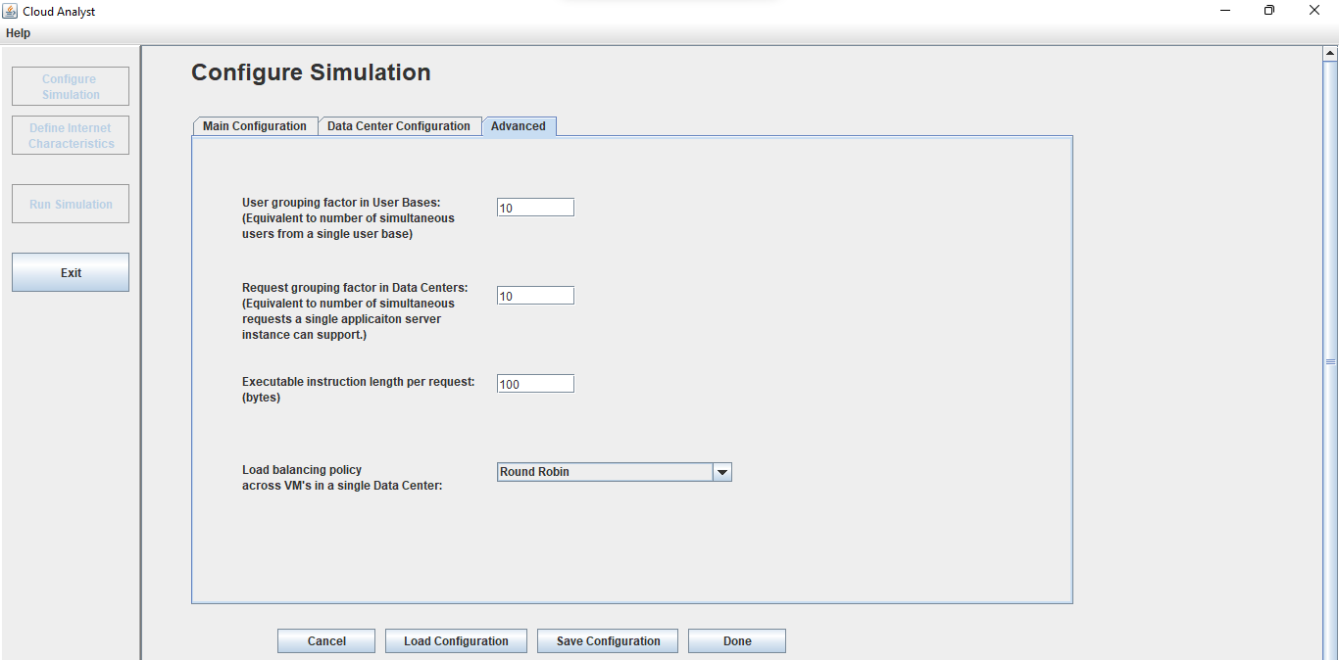

1. Save the configuration if needed

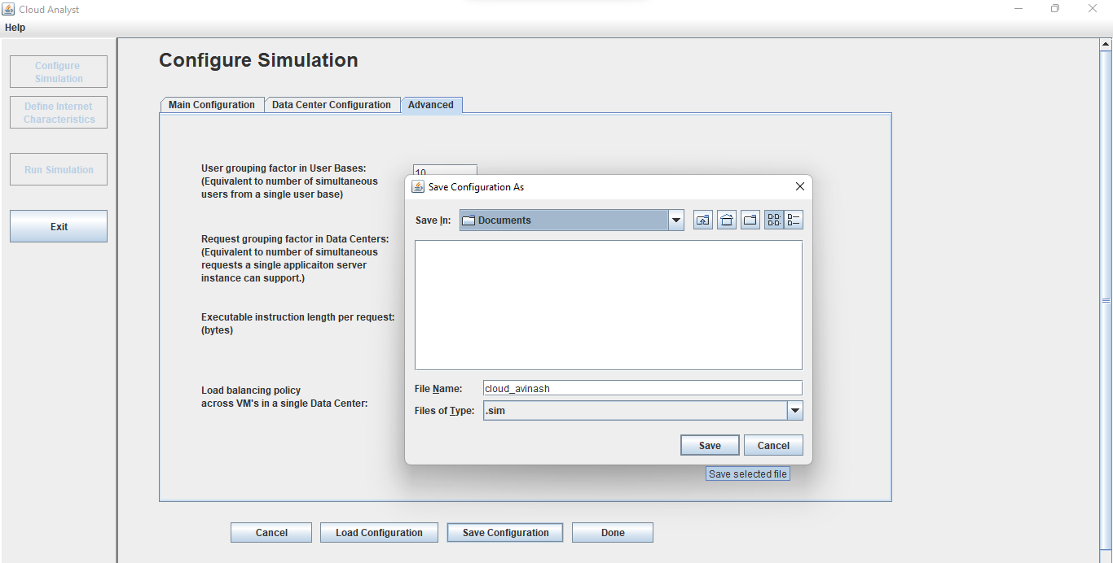

1. Click on done

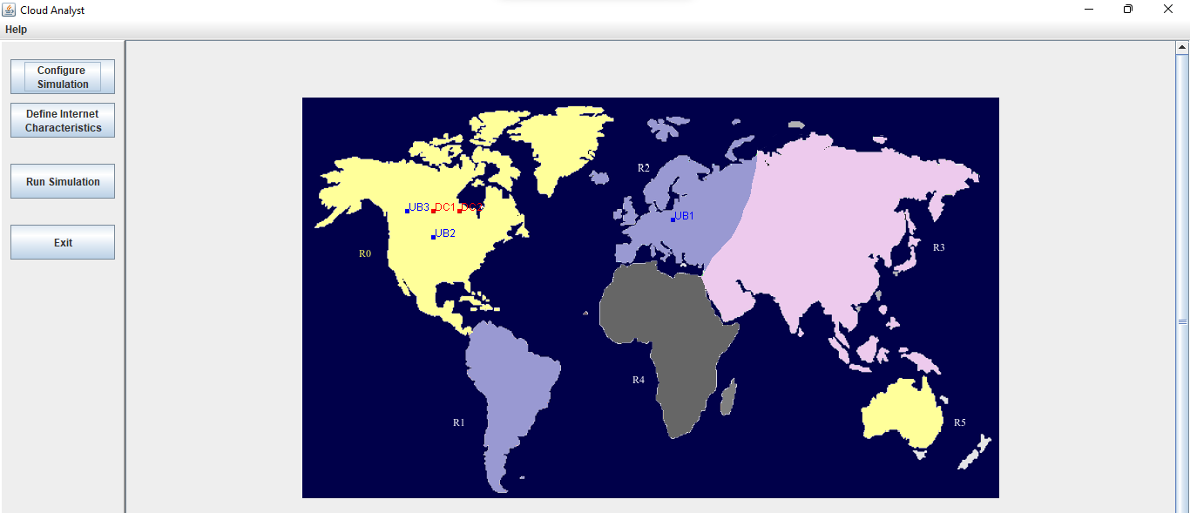

1. Click run simulation

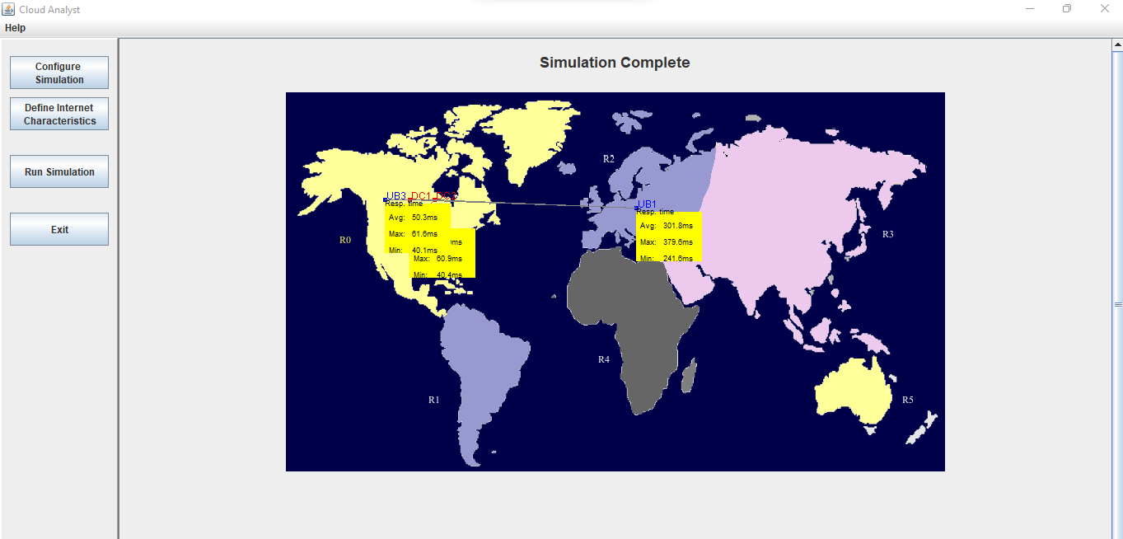

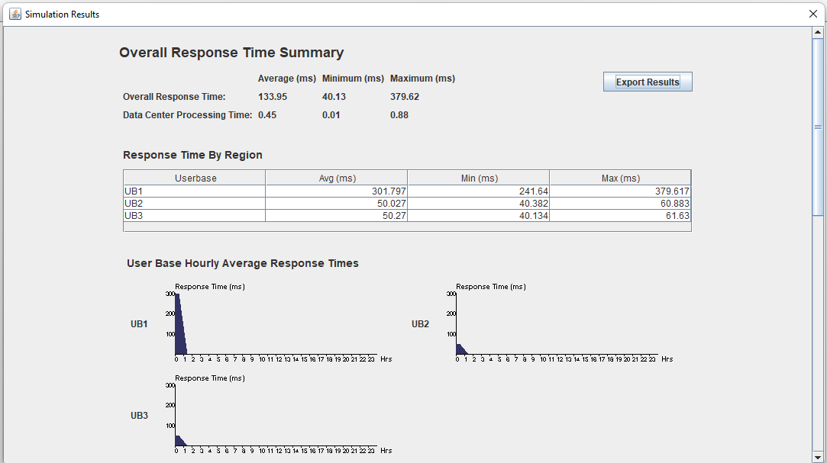

If needed we could change the internet characteristics, Hence we simulated scenario using cloud analyst and also have analysed the cloud performance using this scenario.

**RESULT**:

Hence cloud performance is analysed using cloud analyst tool